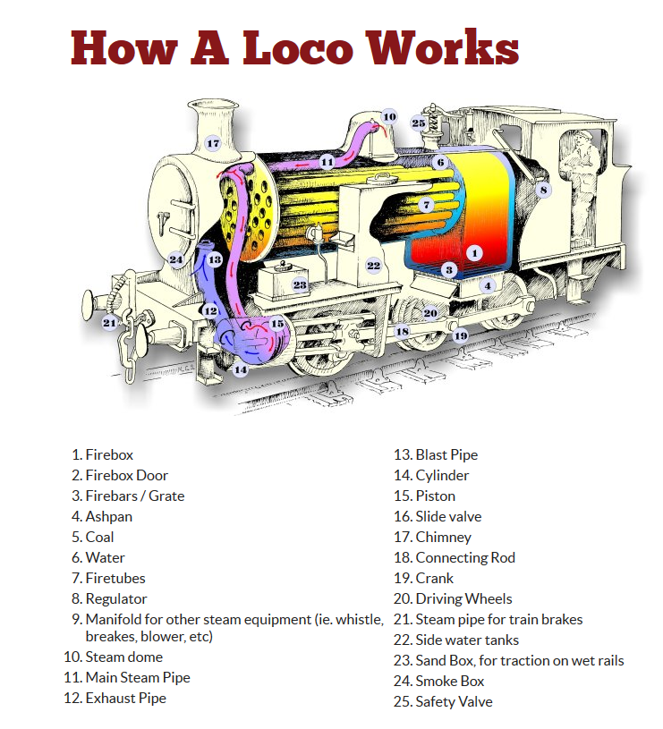

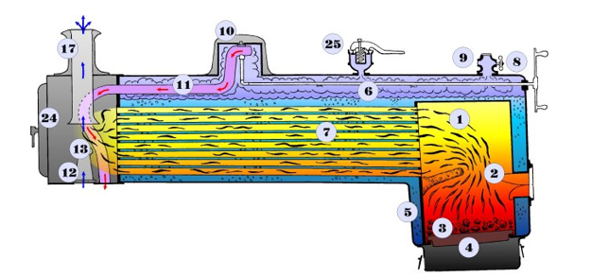

A steam locomotive uses a coal fire (although sometimes wood or oil is used) as its source of energy to boil water and make steam.
The hot gases from the buring coal in the firebox are passsed through the boiler in fire tubes before leaving the locomotive through the smoke box and chimney.
As the water boils, the hot “wet”steam rises, and is collected from the steam dome on top of the boiler through the regulator valve, which the driver uses to control the locomotive speed.
From the regulator, steam is piped to the cylinders and is admitted alternatively via the valve chest (located on each side of the Cylinder housing), pusing the piston in the Cylinder back and forth.
The piston is connected to the driving wheels via the “conecting rod” and “valve gear”(or crank as it may be called), and the to-and-fro motion of the piston turns the driving wheels.
The valve gear on each side of the the locomotive is offset by 90 degrees to prevent it from jamming if the loco stops with them in the horizontal position.
After leaving the cylinder, the spent steam escapes from the locomotive via the blast pipe and up into the chimney in the smoke box. The action of steam in the blast pipe creates a lower pressure in the smoke box, and helps draw the hot gases from the fire through the tubes and in turn genertate more steam.

